Week_3 Report: ( Attack Simulation, Snort Alerts, Alert Format Understanding, and Log Review)
• Simulate attacks (e.g., ping flood)
1. Objective
The objective of Week 3 is to simulate controlled attacks, observe Snort alerts, understand alert format, and review Snort logs.
2. Environment Setup
Two systems were used:
- Attacker System
- Target System with Snort IDS installed
Command used to install Snort: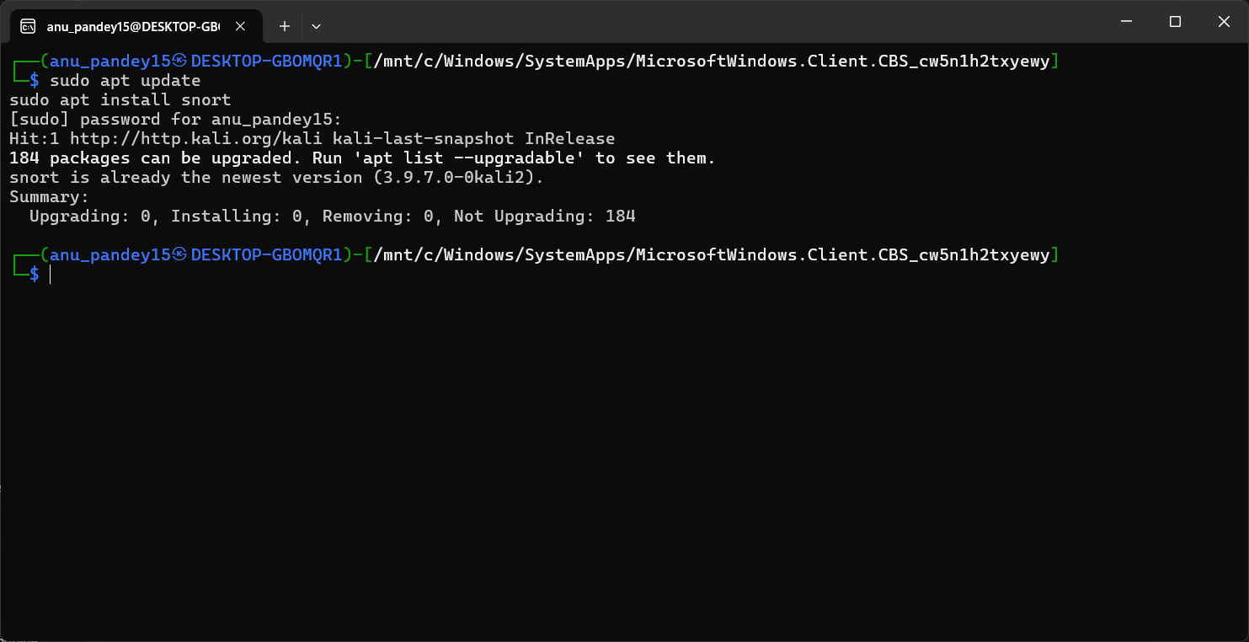

3. Identifying Network Interface
Command used:
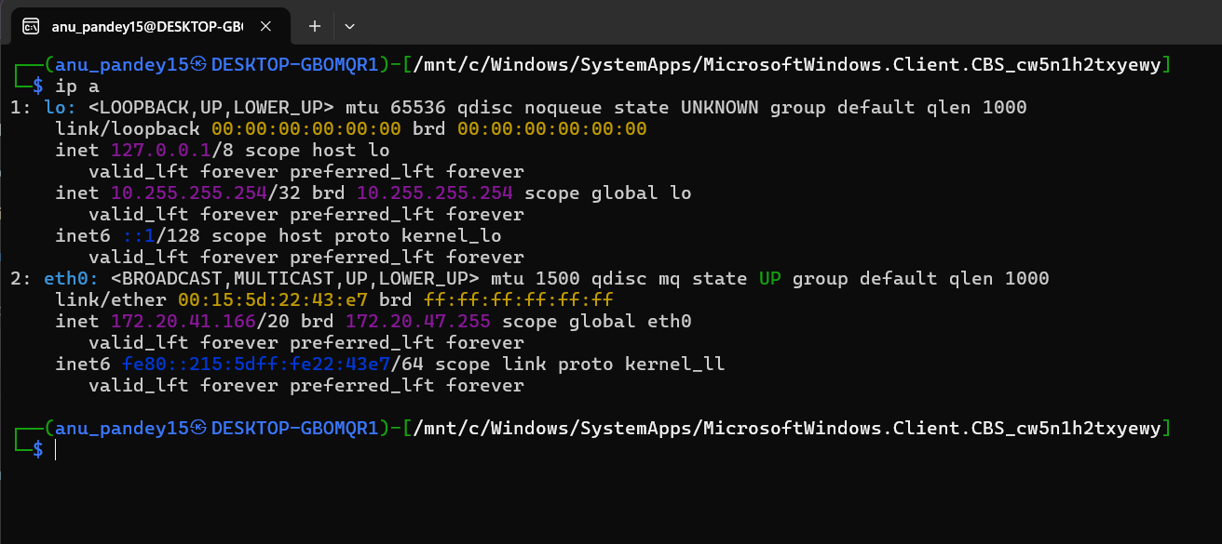

4. Snort Basic Configuration
Opened configuration file:
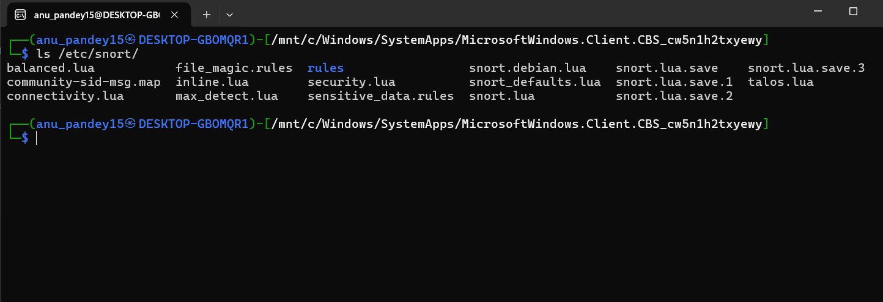

Variables updated :

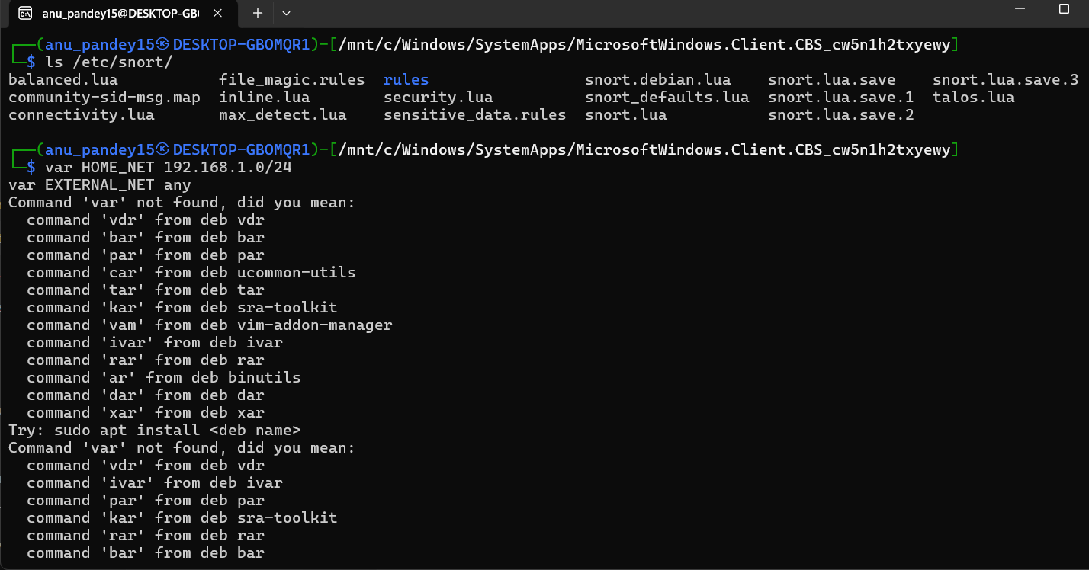
5. Creating a Custom Local Rule
Rule added in:
/etc/snort/rules/local.rules
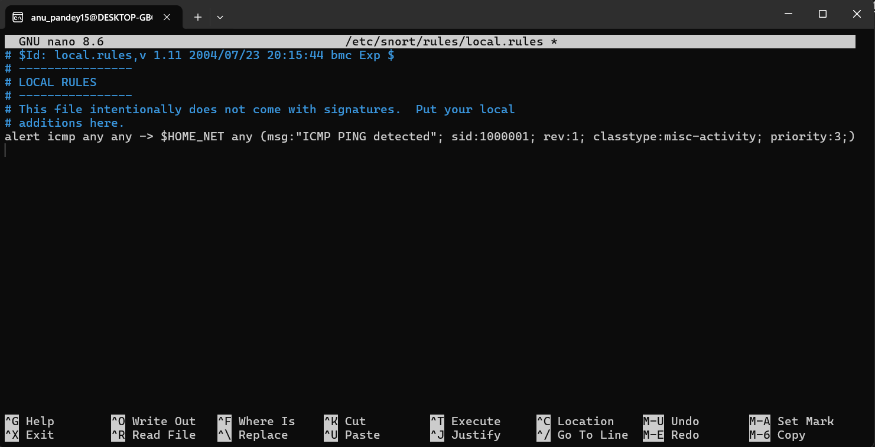

6. Running Snort in IDS Mode
Command used: 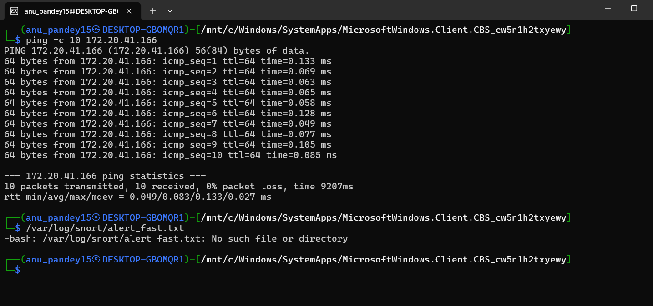
7. Simulating Controlled Attacks
7.1 ICMP Ping Attack
Attacker system:
7.2 Optional: TCP SYN Attack
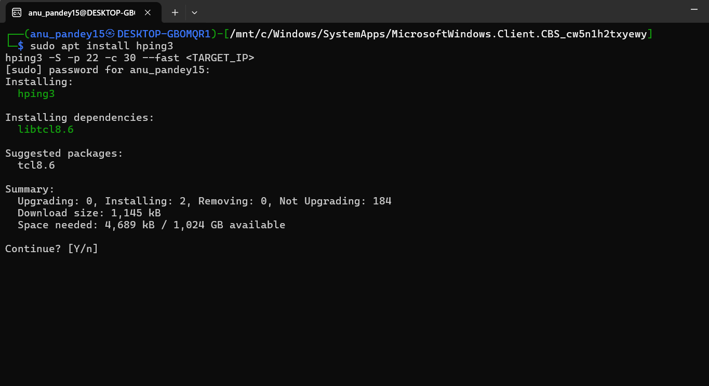

8. Observing Snort Alerts
Snort displayed alerts in real-time.
Logs viewed using:

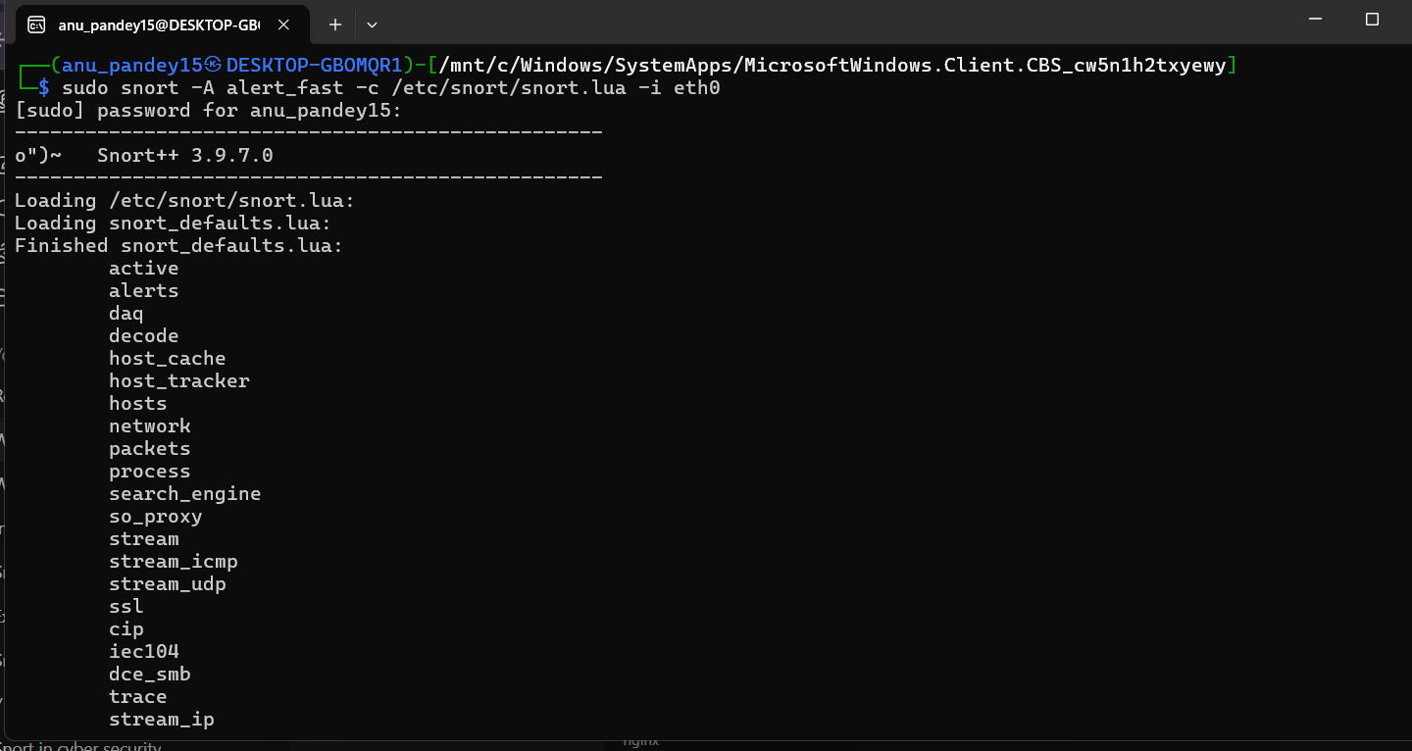

9. Log File Review
Logs located at:
/var/log/snort/alert
Backup created:

